Full Use case descriptions

1 **Make tender application**

|  |  |  |
| --- | --- | --- |
| Use case name: | Make tender application. | |
| Scenario: | Apply for a tender online. | |
| Triggering event: | Application is notified for a new tender to be applied for. | |
| Brief description | Client applies for a new tender online by filling all the necessary information needed. | |
| Actor(s): | Client, Company representative. | |
| Related use cases: | None. | |
| Preconditions: | Standard bidding documents must be provided.  Document composed of the company’s profile must be brought forward.  Tender number must exist. | |
| Post conditions: | Documents received by government employee/Administrator. | |
| Flow of activities: | **Actor** | **System** |
| 1. Client enters login credentials.  2. Client searches for the tender they want.  3. Client clicks on a tender and fills the application form. | * 1. System confirms the username and password then allows access.   2.1 System displays available tenders.  3.1 System saves the application.  3.2 System sends a message of confirmation. |
| Exception conditions: | Tender number isn’t valid. | |

2. **Record payment**

|  |  |  |
| --- | --- | --- |
| Use case name: | Record payment | |
| Scenario: | Record payments made from the purchases of tenders. | |
| Triggering event: | Payments made by Manager. | |
| Brief description | Admin wants to record a payment made by Manager for a particular tender. | |
| Actor(s): | Government employee/administrator. | |
| Related use cases: | None. | |
| Preconditions: | The tender must be complete.  Tender number must exist.  Company number must exist. | |
| Post conditions: | Payment must be recorded on the system. | |
| Flow of activities: | **Actor** | **System** |
| 1. Admin clicks login and enters login credentials 2. Administrator enters payment information. 3. Admin confirms payment information. | 1.1 System grants access  2.1The system saves the information.  2.2 System prompts confirmation.  3.1System records the payment. |
| Exception conditions: | The tender is not complete. | |

3. **Approve tender**

|  |  |  |
| --- | --- | --- |
| Use case name: | Approve tender | |
| Scenario: | Approve a tender application made. | |
| Triggering event: | Applications made by clients. | |
| Brief description | Manager wants to approve a certain tender that has been applied for. | |
| Actor(s): | Manager. | |
| Related use cases: | None. | |
| Preconditions: | The tender application must be complete.  Tender number must exist.  Company number must exist. | |
| Post conditions: | Tender status changes to approved. | |
| Flow of activities: | **Actor** | **System** |
| 1. Manager checks all applications.  2. Manager approves the tender. | 1.1 System displays all applications.  2.1The system saves the information and changes the tender status. |
| Exception conditions: | Basic company info is incomplete on application. | |

3. **Reward tender**

|  |  |  |
| --- | --- | --- |
| Use case name: | Reward tender | |
| Scenario: | A tender must be rewarded to the relevant client/company. | |
| Triggering event: | Applications made for the tender. | |
| Brief description | Manager rewards a tender to a client which qualifies to have it. | |
| Actor(s): | Manager. | |
| Related use cases: | None. | |
| Preconditions: | The tender must be approved.  Application document must be complete. | |
| Post conditions: | Clients must work on the tender. | |
| Flow of activities: | **Actor** | **System** |
| 1. Manager searches all approved tenders.  2. The manager rewards the tender to the client. | 1.1 System displays all approved tenders.  2.1The system saves the client information and waits for the record of payments after completion of tender. |
| Exception conditions: | None. | |

5 **Add Client**

|  |  |  |
| --- | --- | --- |
| Use case name: | Add client | |
| Scenario: | Client details must be added to the system. | |
| Triggering event: | Request for access to the system. | |
| Brief description | Admin enters client details so the client can be registered to access the system. | |
| Actor(s): | Admin. | |
| Related use cases: | None. | |
| Preconditions: | None. | |
| Post conditions: | Client must be able to login to the system. | |
| Flow of activities: | **Actor** | **System** |
| 1. The admin adds the client details. | 1.1The system saves the client information and allows them access to the system. |
| Exception conditions: | None. | |

6 **View tender**

|  |  |  |
| --- | --- | --- |
| Use case name: | View tender. | |
| Scenario: | User wants to view an advertised tender. | |
| Triggering event: | Tender application. | |
| Brief description | User wants to view a tender that has been advertised on our system. | |
| Actor(s): | Admin, Client. | |
| Related use cases: | None. | |
| Preconditions: | Tender must be posted. | |
| Post conditions: | Tender details found. | |
| Flow of activities: | **Actor** | **System** |
| 1. User views an advertised tender. | 1.1 The system provides full tender details. |
| Exception conditions: | None. | |

**SEQUENCE DIAGRAMS**

1. 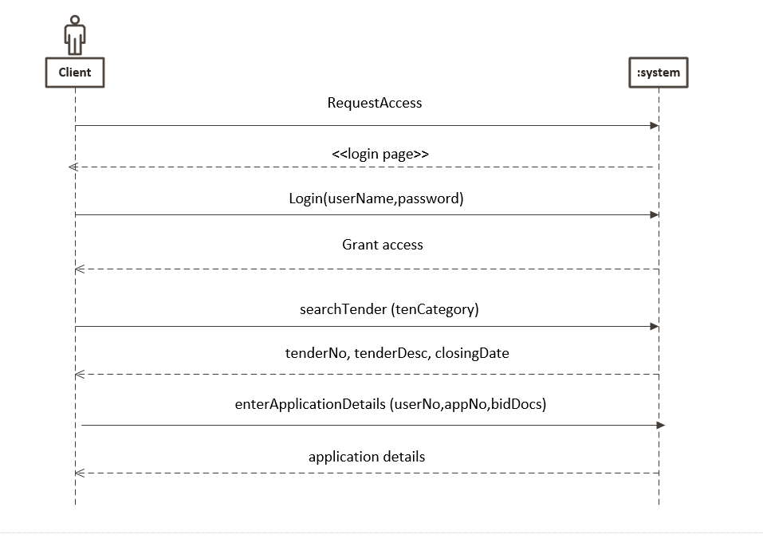**Make tender application**
2. **Make payment**

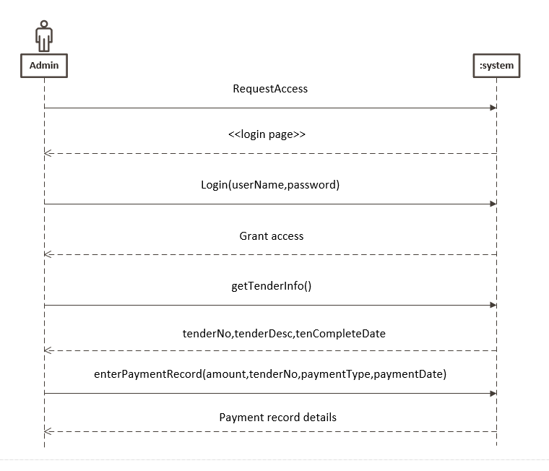

1. **Approve tender**

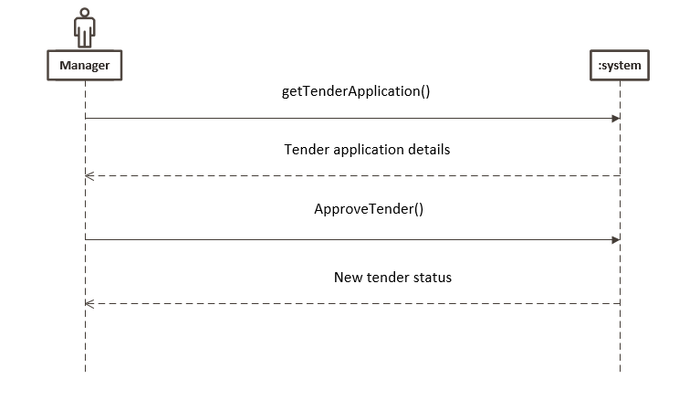

1. Reward tender

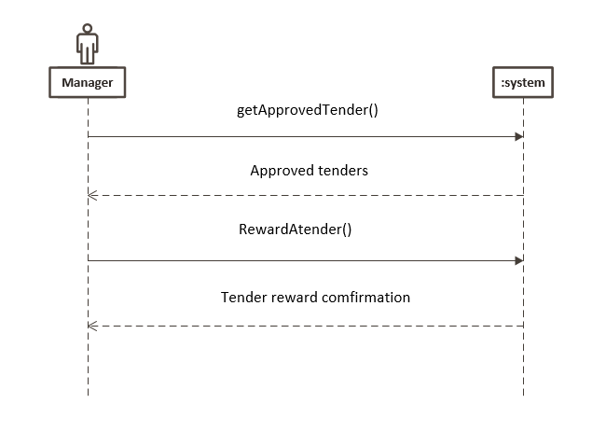

1. View tender

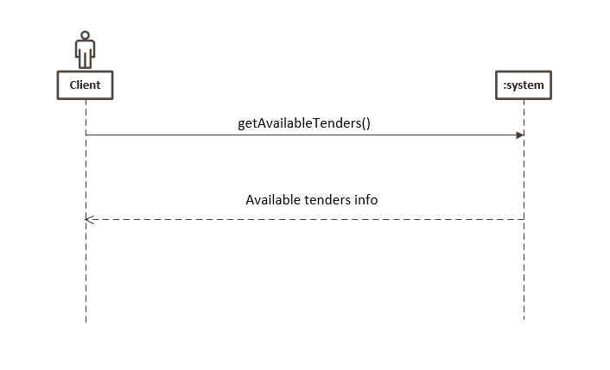

1. Add client

